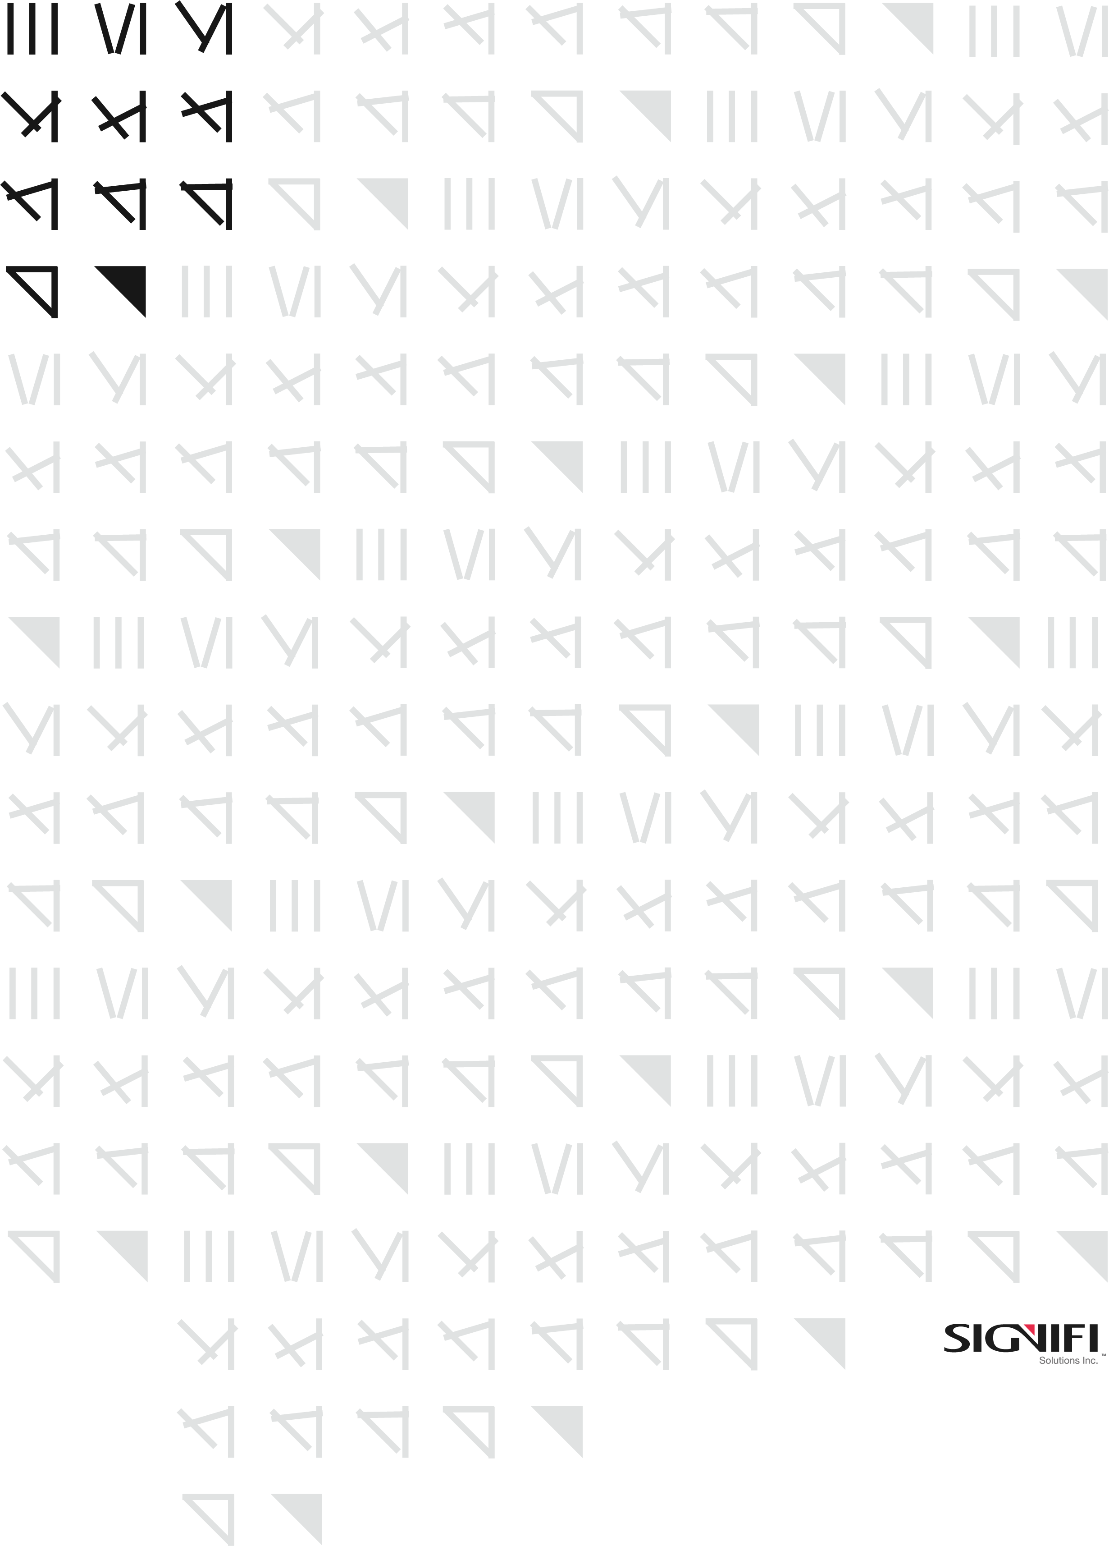

CP01

Company Policies Acceptance Form

|  |  |
| --- | --- |
| Status | Final |
| Version | 1.03 |
| Classification | Confidential |
| Owner | Razvan Anghelidi, Directory of IT |
| Address | 1705 Tech Avenue, Unit 3, Mississauga, ON, L4W 0A2, Canada |

*Statement of Confidentiality: This document and supporting materials contain confidential and proprietary business information of Signifi Solutions Inc. These materials may be printed or photocopied for use internally and must not be shared with other parties.*

Document Control iii

Company Policy Agreement 4

Revision History 10

All rights reserved

No part of this document may be reproduced in any form, including photocopying or transmission electronically to any computer, without prior written consent of Signifi Solutions (from now on, Signifi). The information contained in this document is proprietary to Signifi and may not be used or disclosed except as expressly authorized in writing by Signifi.

Trademarks

Other product names mentioned in this document may be trademarks or registered trademarks of their respective companies and are hereby acknowledged.

Document Control

The electronic version of this document is recognized as the only valid version.

Approval History

|  |  |  |
| --- | --- | --- |
| APPROVER(S) | TITLE/DEPARTMENT | APPROVED DATE |
| Shamira Jaffer | CEO | December 23rd, 2021 |
| Shamira Jaffer | CEO | August 9th, 2021 |
| Shamira Jaffer | CEO | January 12th, 2021 |
| Shamira Jaffer | CEO | January 4th, 2021 |
|  |  |  |
|  |  |  |

Document Sensitivity Level

Confidential

Company Policies Acceptance Form

**THIS COMPANY POLICIES ACCEPTANCE FORM** (“**Agreement**”) dated **August 6th, 2021** is made between signatory and Signifi Solutions Inc. (“Signifi”), 1705 Tech Ave Unit 3, Mississauga, ON, L4W 0A2, Canada.

I have read and been informed about the content, requirements, and expectations of the Signifi policies. I have received electronically a copy of the policies and agree that is my responsibility to comply with and implement all policies and procedures included in Signifi’s policy documents as a condition of representing and maintaining a relationship with Signifi (e.g. employment, partnership or other type as specified in a contract).

I understand that if I have questions, at any time, regarding any policy, I will consult with my immediate manager/supervisor or Human Resources staff members.

I have read the policies carefully to ensure that I understand them before signing this document. I also understand that Signifi may revise, supplement or rescind policies, procedures or benefits, and will provide notice when that happens.

**IN WITNESS WHEREOF** the parties have entered into this Agreement as of the date first above written.

|  |  |  |
| --- | --- | --- |
| Signifi Solutions Inc. | | Signatory |
| By: | By: | |
|  | **(signature)** | (signature) |
| Name: |  | Name: |
| Title: |  | Title: |
| Date: |  | Date: |

If you do not wish to sign, please write here “I refuse to sign the agreement” and sign:  
  
________________________________________________________ Signature: ____________________

List of Policies:

Please review [**Signifi Policies (sharepoint.com)**](https://signifisolutions.sharepoint.com/:f:/s/SignifiCompanyWideSharePointPortal/EjTNKXH3skRAhPf1_m-l__sBhpb_4rjz8RniXGGq62VcMg)

Update

This document will be reviewed and updated annually or upon material changes to Signifi business rules, technology processes, organizational goals, or information security objectives to ensure its continuing suitability, adequacy, and effectiveness.

Revision History

|  |  |  |  |
| --- | --- | --- | --- |
| VERSION | DATE | SUMMARY OF CHANGE | CHANGED BY |
| 1.0 | 2020-12-30 | New template | Sameen Shaikh |
| 1.01 | 2020-12-31 | Added acceptance wording | Razvan Anghelidi |
| 1.02 | 2021-01-11 | Changed wording around relationship between person and Signifi | Razvan Anghelidi |
| 1.03 | 2021-08-06 | Replaced individual document links with the folder link to prevent links breaking when a new updated policy is uploaded | Razvan Anghelidi |
| 1.04 | 2021-12-12 | Annual review | Hadeel AlZuhairi |